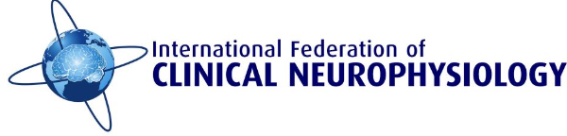

Europe-Middle East-Africa Chapter (EMEAC)

Quantitative EMG and Neuromuscular Ultrasonography Teaching Course 14-16, June 2024
All documents must be received no later than April 5th, 2024

It is a great pleasure to announce this EMEAC-IFCN Hands-on Teaching Course which will take place from 14th to 16th June 2024 in Aarhus, Denmark. Professor Erik Stålberg and other international and Danish experts will share their enormous expertise on EMG, nerve conduction studies and neuromuscular ultrasonography with us. Several hands-on sessions in groups of 5 participants under the supervision of experts will follow the lectures for three days.
The course will be limited to a maximum of 30 participants. These places will be split between applicants from economically disadvantaged and developed countries.
Only applicants from EMEAC-IFCN Societies will be accepted.
The target audience is clinical neurophysiologists in training and neurologists who already have broad experience in routine neurophysiological techniques.
The course is free of change.
Participants will pay for all their expenses including accommodation, travel and food.

EMEAC-IFCN offers travel grants for five participants from low and lower-middle-income countries. Each grant winner will receive €700 for travel and accommodation support. The payment will be made after the completion of the course.

How to Apply
Applicants must attach:
- The application form
- A structured CV, including training to date and publications and any other supporting documents considered appropriate
- Copy of passport or other government-issued ID clearly showing applicant's date of birth (applicant should be 40 years of age or less at the application due date)

Selection of the successful candidates will be made by the EMEAC-IFCN Executive Committee (ExCo). Applicants will be informed of the ExCo decision by April 10th, 2024.

Venue: Aarhus University Hospital, Palle Juul-Jensens Boulevard, 8200, Aarhus N, Denmark

